Nassington Parish Council

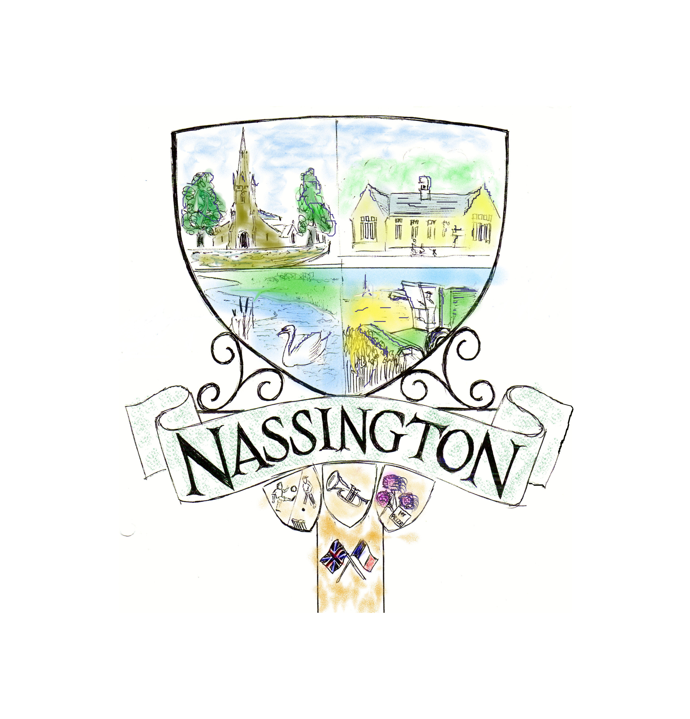

APPLICATION FOR FUNDING – 2025/26
Guidelines
Nassington Parish Council is keen to support local causes and amenities and will do all it can to support fundraising for specific projects or charitable causes.

Any expenditure must be within the constraints of the legal powers limited to Parish Councils and within the bounds of “Best Practice” as ultimately the funds come from the pockets of council taxpayers in the Parish. In addition, the Council is subjected to internal and external audits which examine the grants that are awarded, so the Council must demonstrate that it aware of the issues involved and has taken care in its funding award criteria.

This application document outlines the background to the grants scheme. Application forms should be completed as far as is possible and practicable – do not worry if there is some information that your organisation can’t supply, just fill in what you can. The more information there is, the better, but please be assured that you will not be turned down simply because more information is required before a decision is made.

Please bear in mind the following guidelines when completing your application:

- All grant applications must be submitted on the official grant funding application form, with supporting documentary evidence.
- Grants will be considered by the full council.
- The funds available for grants are very limited and often allocated promptly in the financial year
- In general, the Parish Council will try to support organisations promoting the following initiatives:
  - Promoting local recreational facilities
  - Combating rural isolation
  - Promoting sports, health & fitness
  - Promoting the village or rural affairs
  - Supporting the local economy
  - Providing opportunities to promote educational advancement
  - Projects for children and young people
  - Projects specifically aimed towards senior citizens
- The Council is limited in how much it can grant and to whom grants can be made. Generally speaking, the more tangible the project or scheme and the greater number of people in the Parish that it benefits, the stronger the case
- Grants for assistance in the running (revenue) costs of an organisation will be considered but, in a way as to encourage self-sustainable funding.
- The Parish Council reserves the right to refuse applications or reduce the amount granted and under some circumstances the grant may be provided in kind rather than cash.
- Grants will not be considered, or awarded if previously considered, if the applicant has any monies overdue to the Parish Council, such as hall or pitch hire costs.
- Awards will not be made to:
  - Commercial enterprises set up to generate profit
  - Those supporting party political issues / parties
  - Projects with campaigning objectives
  - Individuals, unless exceptional circumstance warrant otherwise
  - Health, education, or welfare organisations whose services should be provided by statutory funding.
- Awards will not normally be made:
  - To bodies that could be funded by their national or umbrella body (unless for a specific project or exceptional reason)
  - For buildings that are uninsured.
  - For buildings or property not owned by the applicant

- Please be advised that representatives of the Council may visit the site or project in pursuance of their decision-making process or after award of funding
- Payment will be made to an organisation, not an individual
- Retrospective outgoings cannot be applied for
- If your organisation does not have a bank account or constitution, please still get in touch – the council may considering donations of goods or materials instead of a cash donantion.
Grant applications are to be submitted by 31st December 2024 for consideration in the financial period 2025/26, although we may be able to consider applications beyond this date.
This process is designed to be fair and open to all parties. The Council will as far as it is able treat all applications equally and will not discriminate on the grounds of gender, racial or ethnic origin, religion or belief, ethical beliefs, disability, age or sexual orientation. Please try to complete as much of the form as possible.

If there are any points that are unclear or you would like any assistance with completing your form, please contact the clerk, Sarah Rodger, on 01780 435084 or cClerk@nassington-pc.gov.uk . We will do all that we can to assist. You are strongly advised to keep a copy of your completed form for your records

Good luck!

APPLICATION FOR FUNDING – 2025/26
Nassington Parish Council

Application Form
ABOUT YOUR ORGANISATION:
Name

Address
Email address:

Website:

Contact Details: | First Contact | Second Contact
Name:
Position:
Address:

Phone Number:
Mobile Number:
Email Address:

DETAILS OF ORGANISATION STRUCTURE :
Constitution | Do you have a constitution?  Please indicate: YES (Please attach) NO
Status: Are you one of the following? (If not, it does not prevent you from applying for a grant)
Please indicate: | A registered charity? |  |  | A company limited by guarantee? |  |  | Applying for charitable status? |  |  |  | Other: Please state:
When did your group/organization start?
What does your organization do?
Who does your group /organisation serve mainly? | e.g. children, young people, senior citizens, rurally isolated people etc
How many of the people who will benefit from the funding live in the Parish of Nassington
DETAILS OF ORGANISATION FINANCES :
Total income in the last financial year including date of year end.
Total amount spent in the last financial year.
Current unrestricted reserve or savings as of date of application
Current restricted reserve or savings as at date of application.
From what sources does your organisation raise its income? | Income Source |  |  |  |  |  | Amount £
DETAILS OF MANAGEMENT STRUCTURE :
How many people are there on your management committee?
How many staff do you employee?
How many volunteers do you have?
PROJECT SPECIFIC INFORMATION:
Please give more details about the project for which you are applying for this grant:
Please justify the need for this project?
How will you monitor the progress of the project?
How do you plan to judge the success of the project?
TIMESCALE :
Start Date
Finish Date
Ongoing, give details
FINANCIAL INFORMATION ABOUT THE PROJECT :
Please provide a break down of the total cost of this project including VAT (please provide details on a separate sheet if necessary
What funding is your organisation requesting from Nassington Parish Council via this form?
What funds have you raised/applied for so far for this project? |  |  |  |  | Where From |  |  |  | Amount already secured |  | Awaiting Decision
What will happen if you are not successful in this grant application?
IMPACT STATEMENT AND FUTURE MANAGEMENT :
Will this project have a positive effect on the village environment and if so, how?
Please give details of the steps your group/organization is taking to strengthen your group over the coming 12 months. For example, how you are establishing new sources of funding/income or training volunteers/staff.
Declaration I am authorised to make this application on behalf of the above organisation and the information contained in this application is correct. If the information changes in any way I will inform Nassington Parish Council at the earliest opportunity. I give permission for Nassington Parish Council to record the information on this form electronically.
Signed:
Dated:
Please include the following: |  | - Up to date accounts/financial statements & latest report (if available)  - Constitution or a set of rules, if available  - Copies of written estimates or catalogue pages if grant for equipment or capital costs
Please email this application to cClerk@nassington-pc.gov.uk or send with all supporting papers to: Sarah Rodger, Clerk, Nassington Parish Council. 15 Station Road, Nassington PE8 6QB.

Grant Application Proforma 2025/26
Nassington Parish Council

Name of Organisation:

Summary of Project:

Date Application Rec’d: | Notes:
Legal Power: | Notes:
S137 – Maximum proportion based on residents benefiting. | Notes:
Questions/additional information required:

Grant Approved | Grant Declined
Minute Ref: | Minute Ref:
Reason: | Reason:
Amount: | Date Advised Applicant:
Conditions:

Date Advised Applicant:
Cheque Number and Minute Ref:

